Goal Setting and Motivation

Goal setting is a powerful process for thinking about your ideal future, and for motivating yourself to turn your vision of this future into reality.

A small trick for successful goal setting

Set SMART (specific, measurable, attainable, relevant, and time-bound) goals that motivate you and write them down to make them feel tangible

Goals, Wishes, Dreams

A wish is something one potentially desires but is not

prepared to commit to achieving it.

A goal is a well-defined target, something one is

committed to achieving.

A dream is the ultimate destination

Why set goals?

• steer us in the right direction

• drive us forward

• give us focus

• help us determine

• empower us.

Areas of Goal Setting

1.family

2.Health

3.Career

4.Education

5.Finance

6.Spiritual

7.Lifestyle

Points to Remember Before Setting Goals

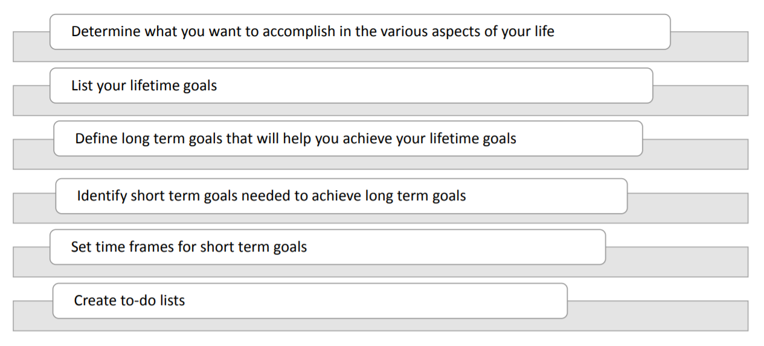

Steps to Goal Setting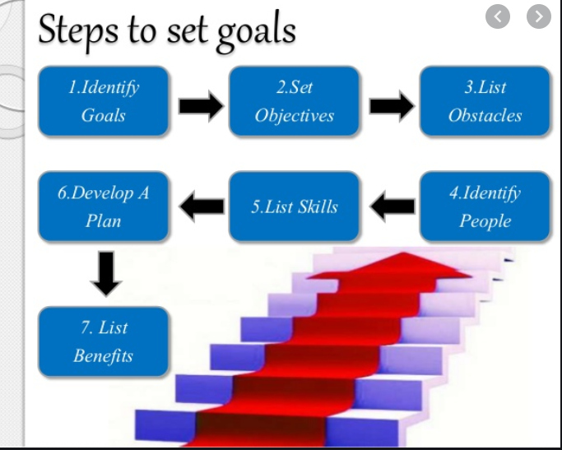

Steps to Prioritizing Goals

1.Select a goal.

2. List goals that are interrelated

3.Add more long-term goals

4.Alwasys be flexible

Types of goals

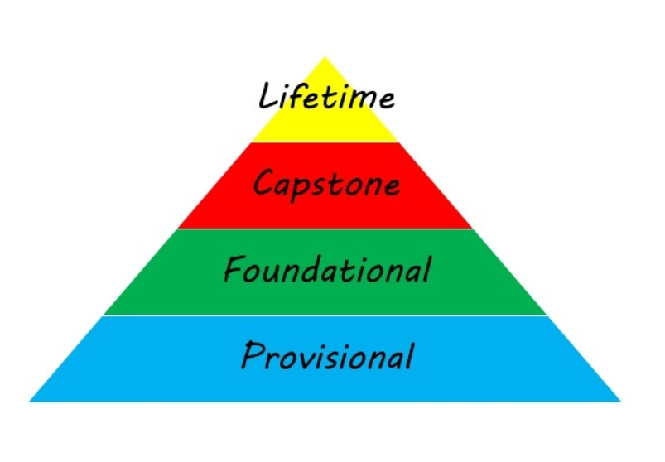

**Lifetime goals**

are those major goals that you would like to accomplish over your lifetime. Depending on your age, these goals may be accomplished significantly later in your life. Typically, these goals will have accomplishment dates of ten or more years in the future.

**Capstone Goals**

Capstone projects are generally designed to encourage students to think critically, solve challenging problems, and develop skills such as oral communication, public speaking, research skills, media literacy, teamwork, planning, self-sufficiency, or goal setting—i.e., skills that will help prepare them for college.

**Foundational**

goals are those short-term goals that will most likely be accomplished in less than one year.

**Provisional Goals**

Provisional (stepping-stone) goals are usually stepping-stones to the larger goals. Typically, these are completed in less than a month. ... However, like Foundational goals, provisional goals can be stand-alone goals with no link to a Lifetime, Capstone, or a short-term goal.

**Benefits of Goal Setting**

- Provides direction

- Helps focus on the important

- Provides clarity in decision making

- Gives you control over your future

- Motivates you

- Gives personal satisfaction, and

- Creates a sense of purpose in life

- Limits stress

Motivation

Motivation is the willingness to exert a persistent

and high level of effort toward organizational goals,

conditioned by the effort's ability to satisfy some

individual need.

Types of Motivation

The Two Main Categories of Motivation

**Intrinsic Motivation**. Intrinsic motivation is a type of motivation in which an individual is being motivated by internal desires.

**Extrinsic Motivation**. Extrinsic motivation, on the other hand, is a type of motivation in which an individual is being motivated by external desires.

Theories of Motivation

1.Maslow’s Hierarchy of Needs

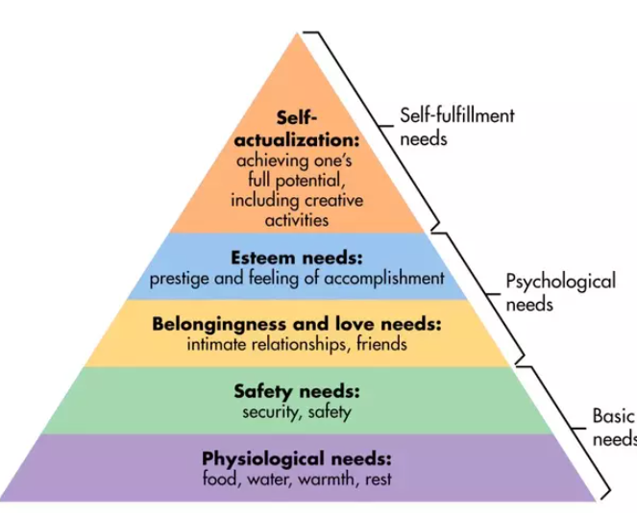

Dr Abraham Maslow, an American psychologist,

propagated a five-tier hierarchy of human needs. He

stated that motivation drives people to achieve certain

needs and certain needs take precedence over others.

The most basic needs are those pertaining to us

physical survival. After achieving each level, an

individual is motivated to move the level above that.

2. ERG Theory

ERG theory is a theory in psychology proposed by Clayton Alderfer. Alderfer further developed Maslow's hierarchy of needs by categorizing the hierarchy into his ERG theory (Existence, Relatedness and Growth). The existence group is concerned with providing the basic material existence requirements of humans. Theory with some modified assumptions and named it the ERG Theory where ERG stands

for:

Existence

Relatedness

Growth

3. Achievement Motivation Theory

David McClelland suggested there are three learned needs: achievement, affiliation, and

power.

Need for achievement (nAch): The drive to excel, to achieve in relation to a set of standards,

to strive to succeed.

(Need for affiliation (nAff): The desire for friendly and close interpersonal relationships.

Need for power (nPow): The need to make others behave in a way that they would not have

behaved otherwise.

4.Douglas McGregor Theory

According to Douglas McGregor:

The concept of Theory X and Theory Y was developed by social psychologist Douglas McGregor. It describes two contrasting sets of assumptions that managers make about their people: Theory X – people dislike work, have little ambition, and are unwilling to take responsibility.

- Theory X basically sees people as irresponsible and lazy

- Theory Y basically views people as responsible and conscientious

5 Goal Setting Theory

• An individual is more likely to be committed to goals when they are self-set,

made public, and when the individual can exercise control over them.

• Self-efficacy is an individual's belief that he or she can perform a

task or can succeed in each task.

• Culture also determines goal setting. Studies have shown that individuals of

western countries are more likely to achieve their goals as the people their rank

high in assertiveness.

6. Equity Theory

• Equity theory predicts that when employees perceive an inequity, they will

make a choice

• Equity theory perceives that individuals are not only concerned with the

amount of rewards they receive for their efforts but also with the relationship of

that amount to what others get.

7. Two-Factor Theory

Proposed by psychologist Frederick Herzberg, it is also known as the motivation-hygiene

theory. Some of Herzberg’s conclusions include:

- Intrinsic factors, such as advancement, recognition, responsibility, and achievement seem to be

related to job satisfaction.

- Job satisfaction factors are separate and distinct from job dissatisfaction factors. Managers who

eliminate job dissatisfaction factors may not necessarily bring about motivation.

- When hygiene factors are adequate, people will not be dissatisfied; neither will they be satisfied. To

motivate people, emphasize factors intrinsically rewarding that are associated with the work itself or

to outcomes directly derived from it.

8. An Integrative Model of Motivation

Its basic framework is organized around the expectancy-theory variables

• Supportive resources facilitate individual effort.

• For good performance, the individual must have the requisite ability to perform

• The performance-rewards relationship will be strong if the individual perceives that

performance is rewarded

• The final link in expectancy theory is the rewards-goals relationship.

**Summary**

-Goal setting is an activity that defines a plan

-Goals act as a compass, steering us in the right direction.

-Goals can be short term or long-term goals.

-Determine what you want to accomplish in the various aspects of your life

-SMART goals are specific, measurable, attainable, realistic, and time bound goals.

-Motivation is the willingness to exert a persistent and high level of effort towards

achieving something

-Motivation is a need-satisfying process.